**ASSIGNMENT -2**

|  |  |
| --- | --- |
| Assignment Date | 29 September 2022 |
| Student Name | Reyan. A |
| Student Roll Number | 211519106123 |
| Maximum Marks | 2 Marks |

Question-1~~:~~

Create form of type input text, email, password, radio button, text area, drop down and navigate to successor page and display files of form in table (CSS, HTML)

Solution:

<html>

<head>

<title>Form</title>

<script type="text/javascript">

function displayDetails()

{

var name = document.getElementById("name").value; var email = document.getElementById("email").value; var gender = document.getElementById("gender").value; var year = document.getElementById("year").value; var pl = document.getElementById("pl").value; document.writeln("<html><body>"); document.writeln("<table border='1'><tr>");

document.writeln("<th>Name</th><th>Email</th><th>Gender</th><th>Program mingLanguage</th><th>Year</th>");

document.writeln("</tr>");

document.writeln("<tr><td>"+name+"</td><td>"+email+"</td><td>"+gender+"</t d><td>"+pl+"</td><td>"+year+"</td>"); document.writeln("</tr></table>");

document.writeln("</body></html>");

}

</script>

</head>

<body>

<form method="post" onsubmit="displayDetails()">

<label for="name">Name:</label>

<input type="text" id="name" name="name" placeholder="Enter name"/><br/><br/>

<label for="email">Email:</label>

<input type="email" id="email" name="email" placeholder="Enter

email"/><br/><br/>

<label for="pwd">Password:</label>

<input type="password" id="pwd" name="pwd" placeholder="Enter password"/><br/><br/>

<label for="address">Address:</label>

<textarea id="address" name="address" rows="4" cols="50"></textarea><br/><br/>

<label for="gender">Gender: </label>

<input type="radio" id="gender" name="gender" value="male">Male</input>

<input type="radio" id="gender" name="gender" value="female">Female</input><br/><br/>

<label for="pl">Programming languages: </label>

<input type="checkbox" id="pl" name="pl" value="java">Java</input>

<input type="checkbox" id="pl" name="pl" value="c">C</input>

<input type="checkbox" id="pl" name="pl" value="python">Python</input>

<input type="checkbox" id="pl" name="pl" value="c++">C++</input><br/><br/>

<label for="year">Year:</label>

<select name="year" id="year">

<option value="first">I</option>

<option value="first">II</option>

<option value="first">III</option>

<option value="first">IV</option>

</select><br/><br/>

<label for="submit">Submit:</label>

<input type="submit" value="submit"/><br/><br/></form></body> </html>

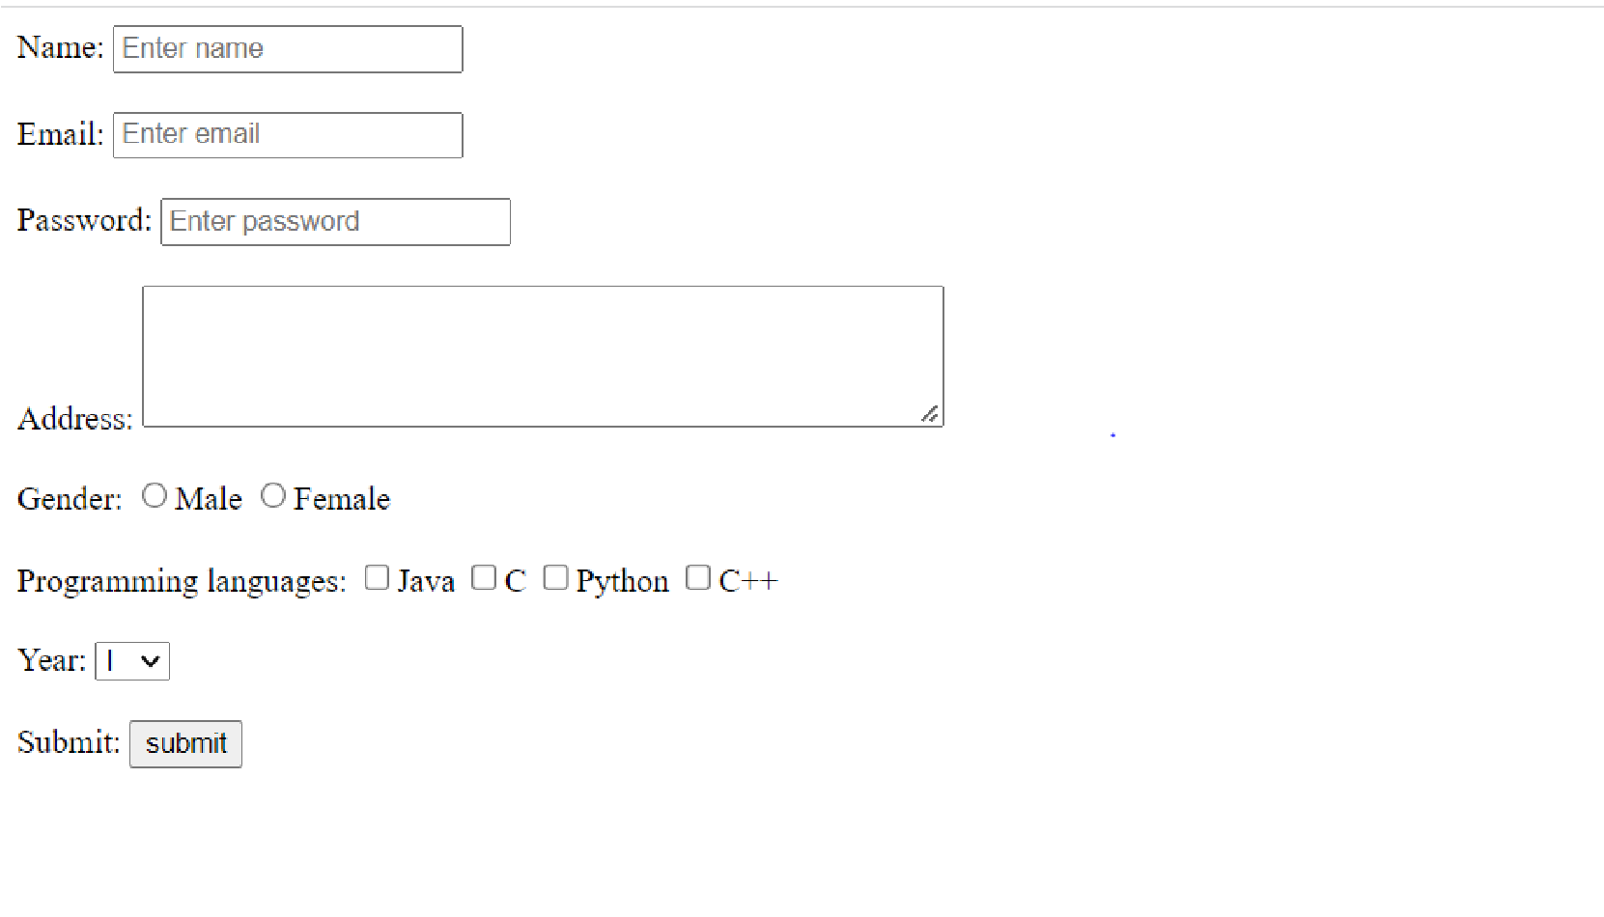

Question~~-~~2~~:~~

For the CSS create external style sheet for above task (separate css file and link that in html)

<html>

<head>

<title>Form</title>

<script type="text/javascript">

function displayDetails()

{

var name = document.getElementById("name").value; var email = document.getElementById("email").value; var gender = document.getElementById("gender").value; var year = document.getElementById("year").value; var pl = document.getElementById("pl").value; document.writeln("<html><body>"); document.writeln("<table border='1'><tr>");

document.writeln("<th>Name</th><th>Email</th><th>Gender</th><th>Program mingLanguage</th><th>Year</th>");

document.writeln("</tr>");

document.writeln("<tr><td>"+name+"</td><td>"+email+"</td><td>"+gender+"</td

><td>"+pl+"</td><td>"+year+"</td>"); document.writeln("</tr></table>"); document.writeln("</body></html>"); }

</script>

<link rel="stylesheet" href="style.css" type="text/css" /></head>

<body>

<form method="post" onsubmit="displayDetails()">

<label for="name">Name:</label>

<input type="text" id="name" name="name" placeholder="Enter name"/><br/><br/>

<label for="email">Email:</label>

<input type="email" id="email" name="email" placeholder="Enter email"/><br/><br/>

<label for="pwd">Password:</label>

<input type="password" id="pwd" name="pwd" placeholder="Enter password"/><br/><br/>

<label for="address">Address:</label>

<textarea id="address" name="address" rows="4" cols="50"></textarea><br/><br/>

<label for="gender">Gender: </label>

<input type="radio" id="gender" name="gender" value="male">Male</input>

<input type="radio" id="gender" name="gender" value="female">Female</input><br/><br/>

<label for="pl">Programming languages: </label>

<input type="checkbox" id="pl" name="pl" value="java">Java</input>

<input type="checkbox" id="pl" name="pl" value="c">C</input>

<input type="checkbox" id="pl" name="pl" value="python">Python</input>

<input type="checkbox" id="pl" name="pl" value="c++">C++</input><br/><br/>

<label for="year">Year:</label>

<select name="year" id="year">

<option value="first">I</option>

<option value="first">II</option>

<option value="first">III</option>

<option value="first">IV</option></select><br/><br/>

<label for="submit">Submit:</label>

<input type="submit" value="submit"/><br/><br/></form></body></html>

style.css body {

background-color:pink; border-style: solid;} table, th, td {

b

o

r

d

e

r

:

1

p

x

s

o

l

i

d

;

}

~~:~~

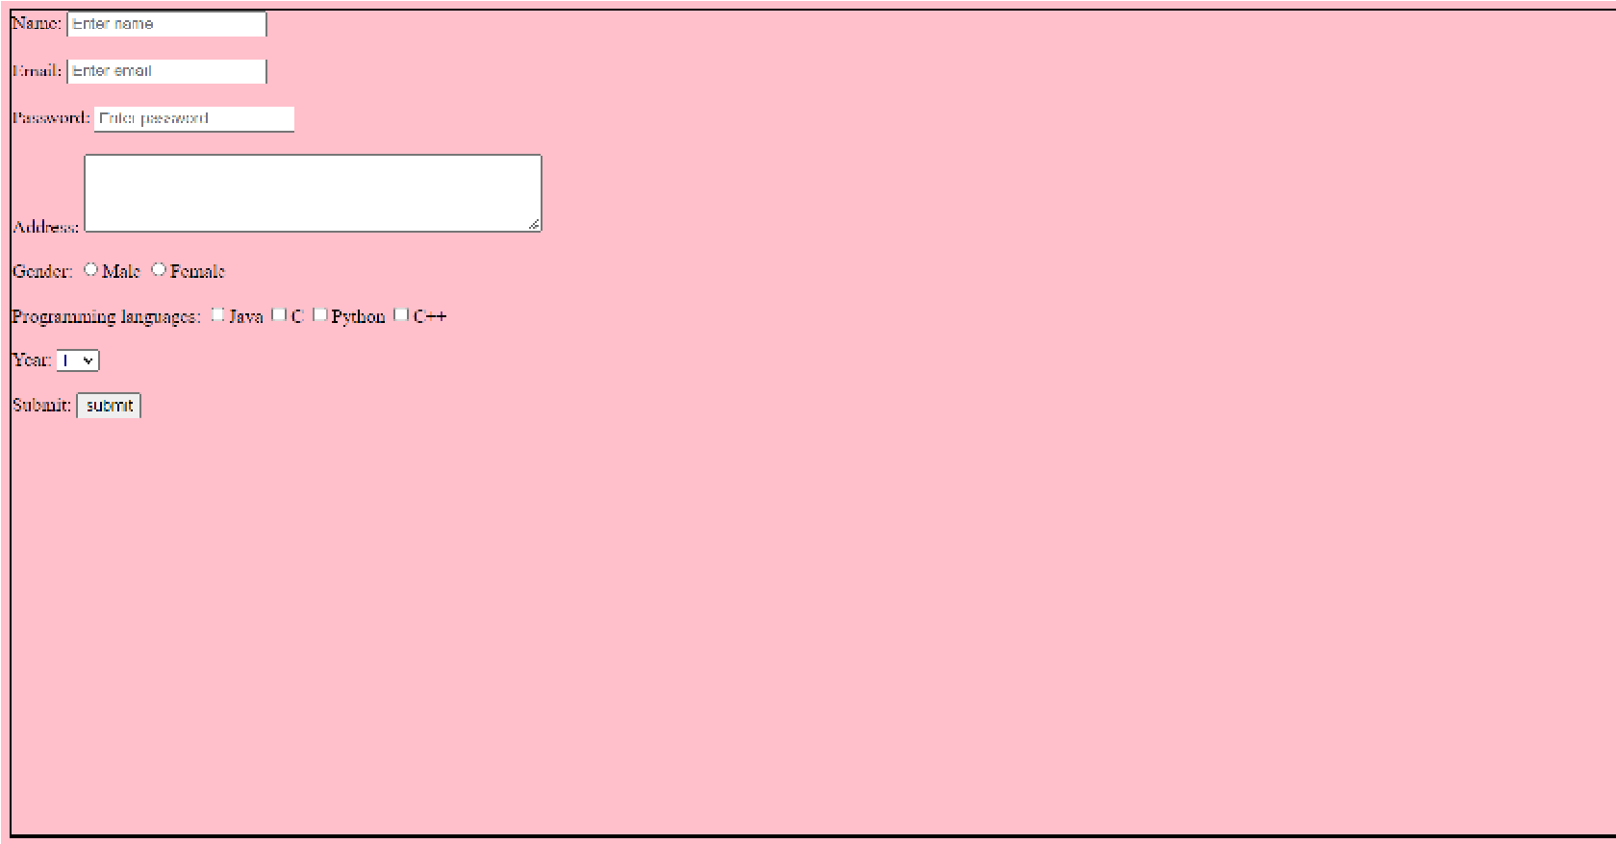

Question~~-~~3~~:~~

Create sample program for Flask HTTP methods (list or map and perform operations of PUT, GET, DELETE and POST)

Solution~~:~~

from flask import Flask,request,json app=Flask(__name__)

cars={"1":"Lamborghini", "2":"Ferrari" , "3":"Porsche" , "4":"Landrover" , "5":"Bugatti",

"6":"Mercedes" ,"7":"Rolls-Royce" , "8":"BMW"} @app.route('/data' ,methods=['GET','POST']) def api():

if request.method=='GET': return cars

if request.method=='POST':

data=request.json cars.update(data) return 'data got inserted'

@app.route("/data/<id>",methods=['PUT']) def update(id):

data=request.form['items'] cars[str(id)]=data return 'data updated'

@app.route("/data/<id>",methods=["DELETE"]) def deleteoperation(id): cars.pop(str(id)) return 'data deleted'

if__name__=='__main__':

app.run(debug=True)

Output:

